Ideation Phase

Empathize & Discover

|  |  |
| --- | --- |
| Date | 18 October 2022 |
| Team ID | PNT2022TMID592713 |
| Project Name | Project - Safeguarding Agriculture: AI-Enabled Prognostication of Farm Insect Threats |
| Maximum Marks | 4 Marks |

# Empathy Map Canvas:

An empathy map is a simple, easy-to-digest visual that captures knowledge about a user’s

behaviours and attitudes.

**Summary:**

The project focuses on using advanced AI technologies to predict and manage insect threats in agriculture. It emphasizes the importance of early detection and prevention to safeguard crops and ensure food production. Farmers and agricultural stakeholders are driven by a desire for effective solutions, a commitment to sustainability, and a sense of community collaboration in their efforts to protect crops and livelihoods while reducing the environmental and emotional impact of pest infestations.

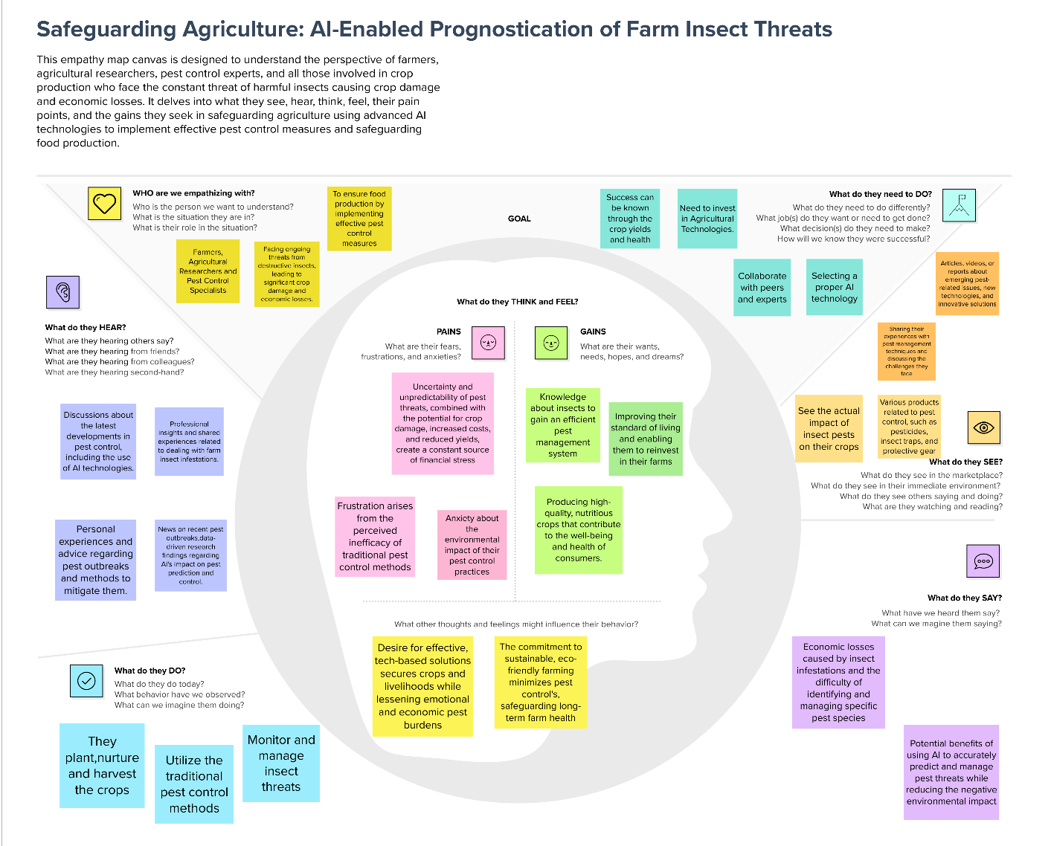

**Link:**

<https://app.mural.co/t/team0070622/m/team0070622/1697632516270/1f6c184a792d4bfe3e73546fa03a060e5e1759f4?sender=ueddbe64e29f13274754b2813>